**Pennsylvania State Police Troop J, Embreeville**

**National Child Passenger Week**

* 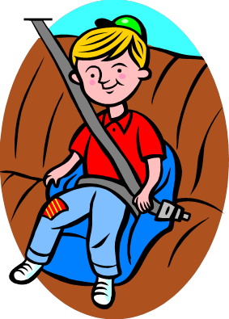*

***Certified child passenger safety technicians will be checking car seats for proper installation. Parents and caregivers will be educated on how to choose the right car seat and how to properly install them in their vehicles. This event is part of the National Child Passenger week and is free to the public.***

***Where: West Bradford Fire Company substation, 1385 Campus Dr, Downingtown, West Bradford***

***When: Wednesday, September 21st from 2:00 PM to 8:00 PM***

***How: For appointments please contact Trooper Waleska GONZALEZ at 610-486-6181. Appointments are not needed but highly recommended.***